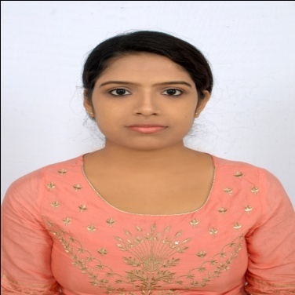CURRICULUM VITAE

PERSONAL INFORMATION:-

NAME:- MS. MOUMITA DAS.

FATHER’S NAME:- SRI. NABA KUMAR DAS.

ADDRESS :- VILL-PADUMBASAN,WARD NO.-10,

TAMRALIPTA MUNICIPALITY,

P.O.+P.S.- TAMLUK

DIST- PURBA MEDINIPUR

PIN-721636

DATE OF BIRTH:- 14/01/1997

NATIONALITY:- INDIAN

SEX:- FEMALE

CASTE:- GENERAL

RELIGION:- HINDUISM

MARITAL STATUS:- UNMARRIED

MOBILE & SMS:- 9064134271

E-MAIL:- [moumitadas.tamluk@gmail.com](mailto:moumitadas.tamluk@gmail.com)

|  |
| --- |
| ACADEMIC QUALIFICATION |

* I AM PURSUING MY POST GRADUATE DEGREE IN COMPUTER APPLICATION(MCA 4TH SEMESTER) (2019-2022) BATCH FROM HALDIA INSTITUTE OF TECHNOLOGY,HALDIA UNDER MAULANA ABUL KALAM AZAD UNIVERSITY OF TECHNOLOGY WITH A YGPA OF 9.03

|  |  |  |  |  |  |  |
| --- | --- | --- | --- | --- | --- | --- |
| DEGREE/  CERTIFICATE | DEGREE | DISCIPLINE | INSTITUTE | BOARD/  UNIVERSITY | YEAR OF PASSING | AGGREGATE |
| 10TH | SECONDARY | GENERAL | RATNALI ADARSHA BALIKA VIDYALAYA | WBBSE | 2014 | 55.42 |
| 12TH | HIGHER SECONDARY | ARTS | BYABATTARHAT ADARSHA HIGH SCHOOL | WBCHSE | 2016 | 67.80 |
| UNDER GRADUATE | BCA | COMPUTER APPLICATION | RAJA N.L. KHAN WOMEN’S COLLEGE | VIDYASAGAR UNIVERSITY | 2019 | 56.36 |
| POST GRADUATE | MCA | COMPUTER APPLICATION | HALDIA INSTITUTE OF TECHNOLOGY | MAKAUT | 2022 | 9.03 |

COMPUTER PROFICIENCY

* + COMPLETED DIPPLOMA COURSE IN INFORMATION TECHNOLOGY APPLICATIONS FROM TAMLUK YOUTH COMPUTER TRAINING CENTER WITH GRADE –“A”.

EXTRA CURRICULAR INTEREST:-

* + PARTICIPATED IN DANCING ,DRAWING ,DRAMA.
  + COOKING ,DRAWING,GARDENING & PLANTING ARE MY HOBBIES.

LANGUAGES KNOWN:-

* + BENGALI(MOTHER TONGUE)
  + HINDI
  + ENGLISH

|  |
| --- |
| SKILL EXPERTISE |

PROGRAMMING LANGUAGES :C,C++,JAVA,HTML,CSS,SQL,PLSQL

OPERATING SYSTEM :WINDOWS

SOFTWARE :VISUAL STUDIO,TURBOC++,MS WORD,

:MS EXCEL,ECLIPSE IDE

SUBJECT INTEREST :JAVA

|  |
| --- |
| OBJECTIVE |

I AM A FRESHER IN THE CORPORATE CULTURE ,BUT READY TO ACCEPT THE CHALLANGES,UTILIZING MY TECHNICAL SKILLS ,WOULD LIKE TO WORK IN HIGHLY ESTEEMED COMPANY WHICH GIVES ME PLATFORM TO USE MY EXPERTISE AND SKILLS FOR MUTUAL GROWTH AND BENEFIT OF COMPANY AND MYSELF.

|  |
| --- |
| DECLARRATION |

ALL THE STATEMENTS FURNISHED ABOVE ARE TRUE TO THE BEST OF MY KNOWLEDGE AND BELIEF; AND FOUND ANYTHING FALSE ,MY CANDIDATURE WILL BE LIABLE TO BE REJECTED WITHOUT FURTHER INTIMATION TO ME.

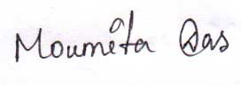

...........................................

SIGNATURE OF THE CANDIDATE